1. **For the DFA M below, give its formal definition as a quintuple. Verbally describe the language, L(M), accepted by M.**

M1 = (Q, Σ, δ, q1, F)

* + 1. Q = {q0, q1, q2, q3}
    2. Σ = {1,0}
    3. δ =

|  |  |  |
| --- | --- | --- |
|  | 1 | 0 |
| q0 | q3 | q1 |
| q1 | q2 | q1 |
| q2 | q2 | q2 |
| q3 | q3 | q1 |

* + 1. q0
    2. F = {q3, q1}

If there exists a 1 after any zero, reject, else, accept.

1. **For each of the following languages over the alphabet = {a, b}, give a DFA that recognizes the language.**
2. **M1 = (Q, Σ, δ, q1, F)**
   * 1. Q = {q0, q2, q3}
     2. Σ = {a,b,λ}
     3. δ =

|  |  |  |  |
| --- | --- | --- | --- |
|  | λ | a | b |
| q0 | q2 | q3 | q2 |
| q2 | q2 | q2 | q2 |
| q3 | q3 | q3 | q2 |

* + 1. q0
    2. F = {q2}

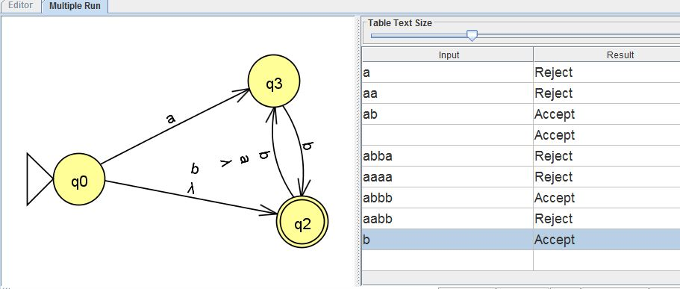

**B) M1 = (Q, Σ, δ, q1, F)**

* + 1. Q = {q0, q1, q2}
    2. Σ = {a,b}
    3. δ =

|  |  |  |
| --- | --- | --- |
|  | a | b |
| q0 | q1 | q0 |
| q1 | q1 | q2 |
| q2 | q1 | q2 |

* + 1. q0
    2. F = {q2}

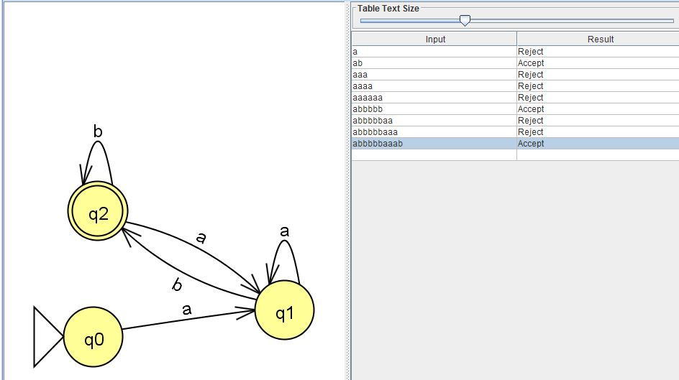

**C) M1 = (Q, Σ, δ, q1, F)**

* + 1. Q = {q0, q1, q2}
    2. Σ = {a,b}
    3. δ =

|  |  |  |
| --- | --- | --- |
|  | a | b |
| q0 | q1 | q0 |
| q1 | q2 | q1 |
| q2 | q0 | q2 |

* + 1. q0
    2. F = {q1}

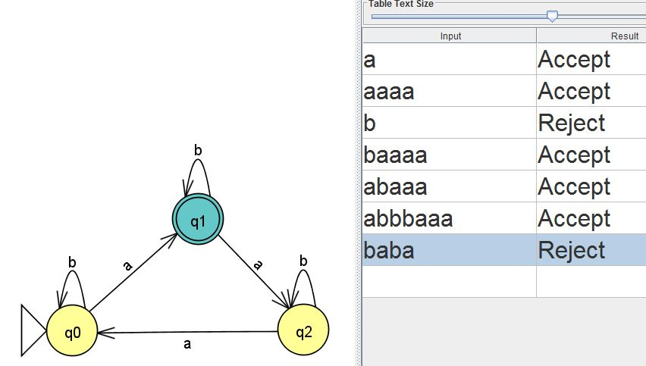

**D) M1 = (Q, Σ, δ, q1, F)**

* + 1. Q = {q0, q1, q2}
    2. Σ = {a,b}
    3. δ =

|  |  |  |
| --- | --- | --- |
|  | a | b |
| q0 | q1 | q0 |
| q1 | q2 | q1 |
| q2 | q0 | q2 |

* + 1. q0
    2. F = {q0,q2}

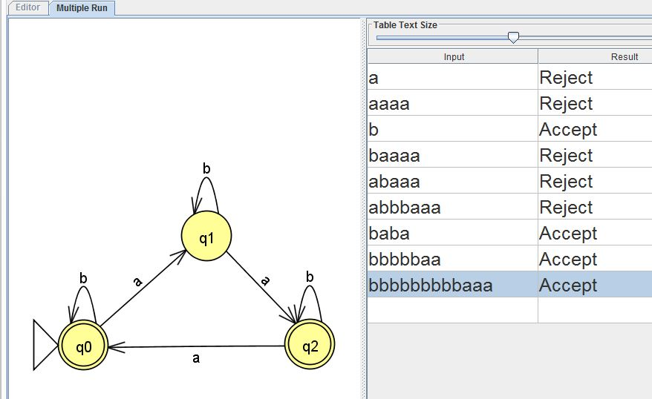

1. **Let L = {w {0, 1}* such that w is a binary representation of an odd integer}. Show that L is a regular language.**
   1. Q = {q0, q1}
   2. Σ = {0,1}
   3. δ =

|  |  |  |
| --- | --- | --- |
|  | 0 | 1 |
| q0 | q0 | q1 |
| q1 | q0 | q1 |

* 1. Q0
  2. F = {q0,q1}

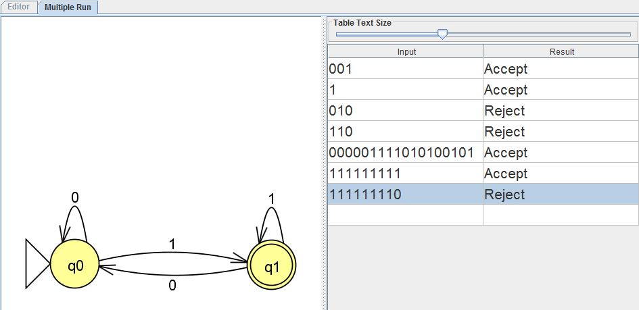

1. **Prove that the class of regular languages is closed under complementation. That is if L is a regular language then 𝐿̅ is also a regular language.**

Given a universal set of all numbers in a binary format, we can say that L is a list of all the odd numbers, and L is a regular language, L itself is a subset of the universal set, and as such, the complement of L, which would consist of all non-odd values exist outside of the normal L subset. Both are regular languages, but possess no overlap.

For an example, our language will be L = {w {0, 1}* such that w is a binary representation of an odd integer. }

* + 1. 
    2. Next we will get the compliment by switching every node’s final state status.
    3. 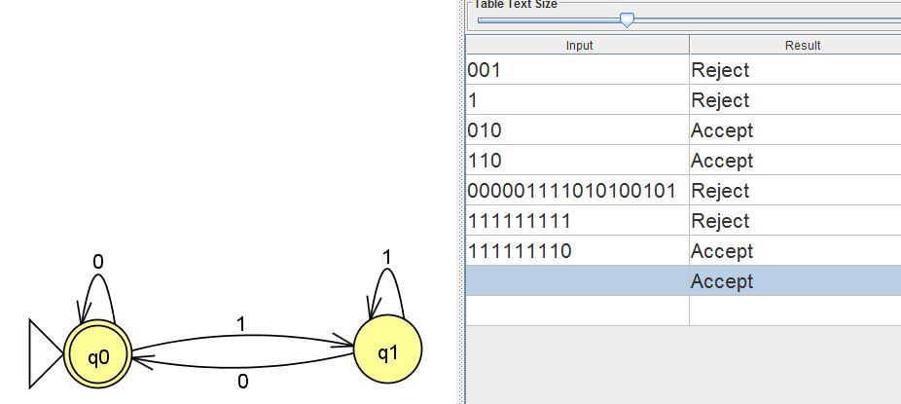
    4. Now we have the complemented DFA, which would mean that we have our language: Our language will be L = {w {0, 1}* such that w is a binary representation any non odd integer value. }